MS SQL SERVER
Standard Operating Procedures
(SOP)
Restore TDP DB Backup to Different Instance

Submitted to



BY



CIS, Wipro Limited

Document Details
Project Name | Innogy SE
Account | CIS
IT Component/Application Title | SQL Server 2012 Patching
Current Version | 1.0
List of Contributors | Ayushi Srivastava
Customer Contact Information

Version History
(All revisions made to this document must be listed in chronological order. All revisions must be approved. Review and Approval can be done by an internal source or by the customer)
Version | Date of Revision | Description | Author | Reviewed By | Approved By
1.0 | 22-02-2019 | Complete Document | Ayushi Srivastava | Pradipkumar Kansara | Santosh Badiger
Document Distribution List
S.No | Name and Company | Purpose
1 | RWEIT-SQLDBA | Document is useful for maintaining SQL agent security.
2

TABLE OF CONTENT

1. Purpose 1
2. Scope 1
3. SQL Server Patching 1
8. Reference 11

Purpose
This document is prepared for Restoring database backup which is being taken online by TDP SQL Backup and Restoration tool to a different SQL Server Instance( from production server to a non-production server).

Scope
This document is prepared for GSMC Wipro sustenance team and provides the concepts of restoring a database backup from TDP SQL Tool to a different instance.

About the tool
Tivoli® Storage Manager for Databases is used for the purpose of Data Protection for Microsoft SQL Server to protect business-critical databases with automated tasks, utilities, and interfaces.
TDP SQL is a tool which we use to take backup of databases. TDP SQL will not create any backup file(i.e. .bak file), however it will directly take backup of data files(.mdf, .ndf files) to TSM server.

Pre-requisites
- Last database full backup should exist in the Tivoli Storage Manager.
- Must have the source and destination database server instance name respectively.

Steps to Restore Full Database Backup

The following steps can be use to restore a database to an alternate location.

1. Copy the "dsm.opt" file from the originating (source) machine where the backup was taken to this alternate (target) restore machine (the default directory is c:\program files\tivoli\tsm\tdpsql).
In our environment, the path for dsm.opt file is C:\TSM\TDPSql

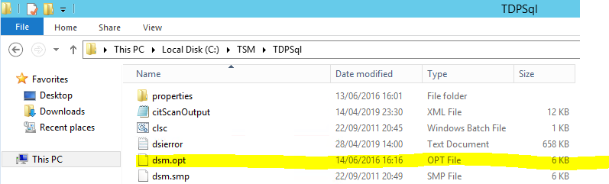

2. If password access is set to generate in this "dsm.opt" file, it may be necessary to reset the password on the Tivoli Storage Manager Server for this node.(Check with Backup Team for the same)
3. Launch the Data Protection for SQL GUI on the alternate (target) restore machine.

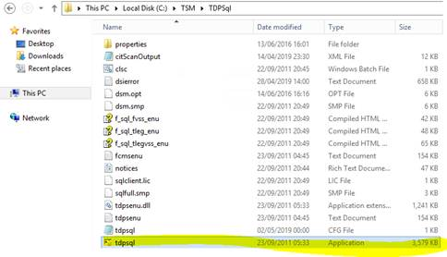
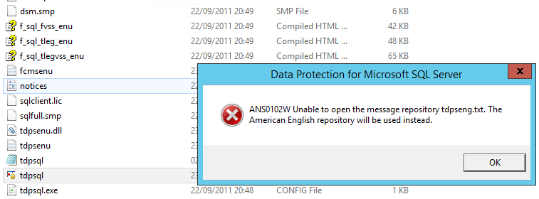

Click OK.

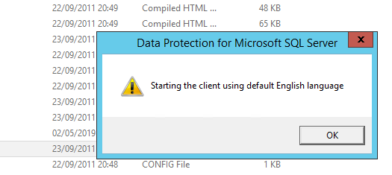

4. Expand SQL Server and click on the Restore Databases tab.
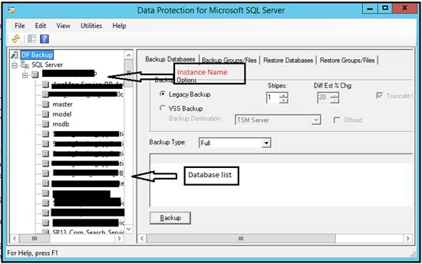

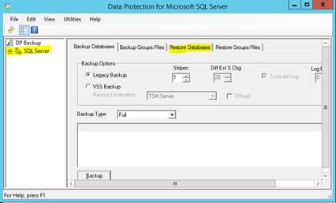

5. If this is the first time this node has attempted to contact the Tivoli Storage Manager Server from this machine, it will prompt for the Tivoli Storage Manager password. (Check with Backup Team for the same)

6. Make sure that both boxes are checked for the Wait for Tape Mounts (for both the Restore and for File Information).

Depending on which database backup is being restored, it may be necessary to check the Show Active and Inactive box.

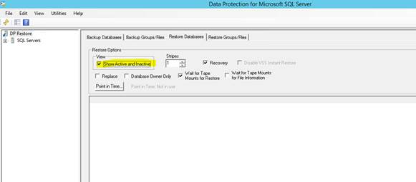
If this restore is going to replace an already existing database on this alternate restore machine, also make sure the Replace check box is selected.

On the left-hand side, under SQL Servers, open the list to see the SQL Server and databases from the originating (source) machine.

8. In the main restore window, select the database to be restored (the box next to the database should have a red check mark).

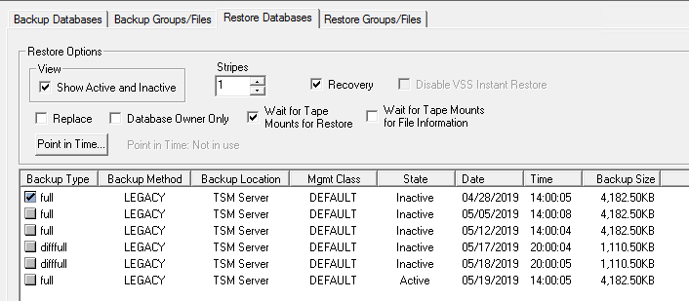

9. Right click on this selected database and 3 options will be displayed: Restore Into, Relocate, Stand Server Undo File.

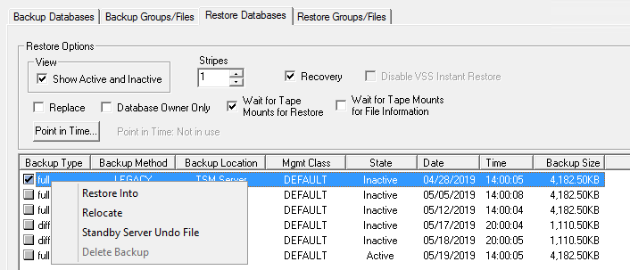

10. Both the Restore Into and Relocate options will need to be configured.
a. Select the Restore Into and enter the new name for this database on this alternate (target) restore machine.

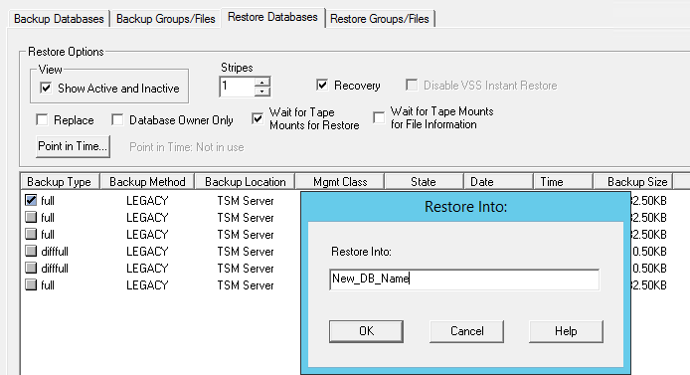

b. Then select the Relocate, wait for the dialog box to appear that contains the information regarding the file location/name for the database backup. If the metadata containing this information must wait for a tape mount on the Tivoli Storage Manager Server, it may be some amount of time until the dialog box is populated. It is not possible to update the relocate information until after the box has been filled in with this File Information metadata.

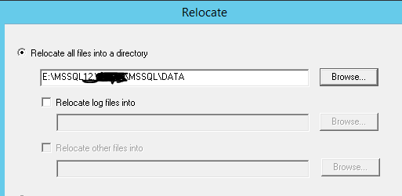
11. If there are multiple objects (a full, differential, logs) selected for the restore, then the Restore Into will need to be specified for each, but the Relocate is only necessary for the full database backup as all the logs will be written based on the paths specified for the full.
12. Then click the Restore button to complete the restore to this alternate (target) restore machine.
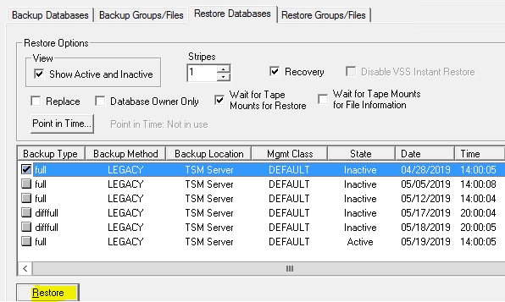

Reference:
Please refer below link to restore the database backup to a different instance using Tivoli Storage Manager.
http://www-01.ibm.com/support/docview.wss?uid=swg21105967

